2018 Yoga Teacher Training
Scholarship Application

The Tree South LA Yoga Teacher Training (YTT) program seeks to diversify yoga by training yogis from underrepresented groups to become yoga instructors. We emphasize yoga as a tool for social justice and community building.

We have a limited number of scholarships available for the 2018 YTT class. The scholarship rate is $800 (40% of the full tuition rate) + 30 hours of work-trade for the studio. Our YTT Scholarship Committee will review all applications thoroughly and select scholarship recipients based on the following criteria:

Qualifications
In order to qualify for the YTT scholarship rate, the applicant must:

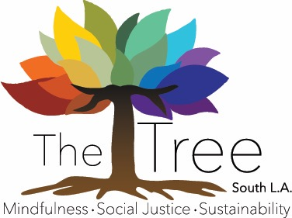
- Demonstrate financial hardship that would otherwise prevent participation in the YTT program. Must provide past three months of bank statements with application.
- Demonstrate a commitment to community service and social justice.
- Be a member of an underrepresented group within yoga (e.g., male, person of color, lesbian/gay, bi-sexual, transgender, questioning, etc.) OR Be a member of the South Los Angeles community (e.g., grew up here or currently live or work in South L.A.)
- Answer the essay questions below and submit this completed Scholarship Application form along with the YTT Program Application form.

Requirements
If the scholarship rate is awarded, the recipient of the scholarship is required to:
- Complete 30 hours of work-trade (unpaid, volunteer hours) to supplement the cost of the training (60% discount from the full tuition cost).
- Upon successful completion of the YTT program, commit to teaching yoga/meditation in an underserved community for 1 year.

2018 Yoga Teacher Training
Scholarship Application

Applicant Info
First Name: Last Name:
Address:
City: State: Zip:
Email: Phone:

If I am awarded the scholarship rate, I ________________________________, will fulfill all the obligations of the YTT program and further,
- Commit to 30 hours of work-trade to supplement the cost of the training and pay $800 (scholarship tuition rate)
- Upon successful completion of the YTT, commit to teaching yoga/meditation in marginalized communities for 1 year.
- If Work Trade hours are not completed by two months after graduation, I will pay the balance due.

_______________________________________ _____________
Applicant Signature Date

Completed applications can be submitted to our studio:

The Tree South LA
8227 S. Western Ave.
Los Angeles, CA 90047
OR
Emailed to us at: info@thetreesouthla.org

- SCHOLARSHIP APPLICATION IS DUE Friday, September 8th 2018
- Interviews will be held the week of September 10th 2018
- Final decisions will be made by Monday, September 17th 2018

ESSAY #1: FINANCIAL HARDSHIP
In the space provided, please share with us how the scholarship rate will help you to participate in The Tree’s YTT program. Describe your financial situation (i.e., any dependents, other responsibilities or special circumstances, etc.). Provide only what are comfortable sharing, but give us a sense as to why you are requesting the reduced tuition rate.

ESSAY #2: COMMUNITY/SOCIAL JUSTICE
The Tree is a social justice organization with a strong commitment to community service. We expect that our YTT grads embody this same commitment to serving and building community.
- Describe your community-service experience (paid or volunteer).
- How would being a certified yoga instructor add to your community work?

ESSAY #3: GROUP
A stated goal of The Tree’s YTT program is to diversify yoga.
- Describe how your unique perspective/experience (i.e., as a male, LGBT, POC, South LA resident, etc.) is not represented in mainstream Western yoga spaces.

ESSAY #4: OPTIONAL
Is there anything else you would like to share with the selection committee?

THANK YOU & GOOD LUCK!

